Games Programming 3

**McIntyre, Lewis, S2028246, Software Dev**

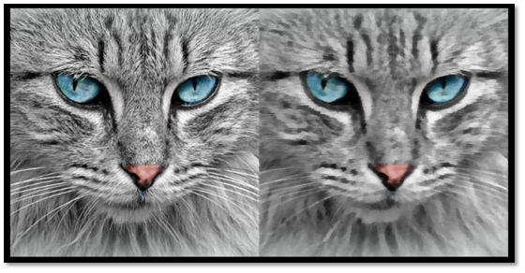

**Declaration**

*I confirm that the code contained in this file (other than that provided or authorised) is all my own work and has not been submitted elsewhere in fulfilment of this or any other award.*

*Signature. Lewis McIntyre*

[Project OneDrive](https://caledonianac-my.sharepoint.com/:f:/g/personal/lmcint218_caledonian_ac_uk/EnBbuH785K1Au2ELgr1dSQkBwwy7rubRf8x-f7wVLhmnMA?e=xn1oTU)

[Project GitHub](https://github.com/LewisMcI/Games-Programming-3)

[Video](https://youtu.be/-TT5uQZrLR8)

# Note of major extension done

* Entity Component System
* Frame Buffer Object (Kuwahara Filter)
* Assimp Model Loading (Went from about 23 seconds to load Ship.fbx, to 15)
* Model Binary Loading (Went from about 15 seconds to load Ship.fbx, to 6)
* Model Loading Optimisation (Load only once, when required)
* SFINAE Test to auto subscribe any component with an onUpdate method to the onUpdateEvent
* Added GlobalVariables
* Quaternion TransformComponent
* Partial Timestep management
* Data Structures - Singleton & EventSystem

# Keys & Usage

Freecam - WASD - MOVE   
FirstPerson|ThirdPerson - W & S Forward & Back - Mouse in direction to rotate

C - Swap Camera

Left|Right Mouse - Fire

There is a GlobalVariables.h in the Other folder, with access to:

* Display Width & Height
* FPS Counter
* Timestep Management (Could not get to work for Audio)

# Credit

[Assimp Model Loading - Code Imposter](https://www.youtube.com/watch?v=GovbphOagoQ)

[Entity Component System (ECS)](https://www.youtube.com/watch?v=Z-CILn2w9K0)

Chatgpt used throughout for code creation and validation.